- Go to www.beingwell.yale.edu
- From the home page, click on the Weight Management page.
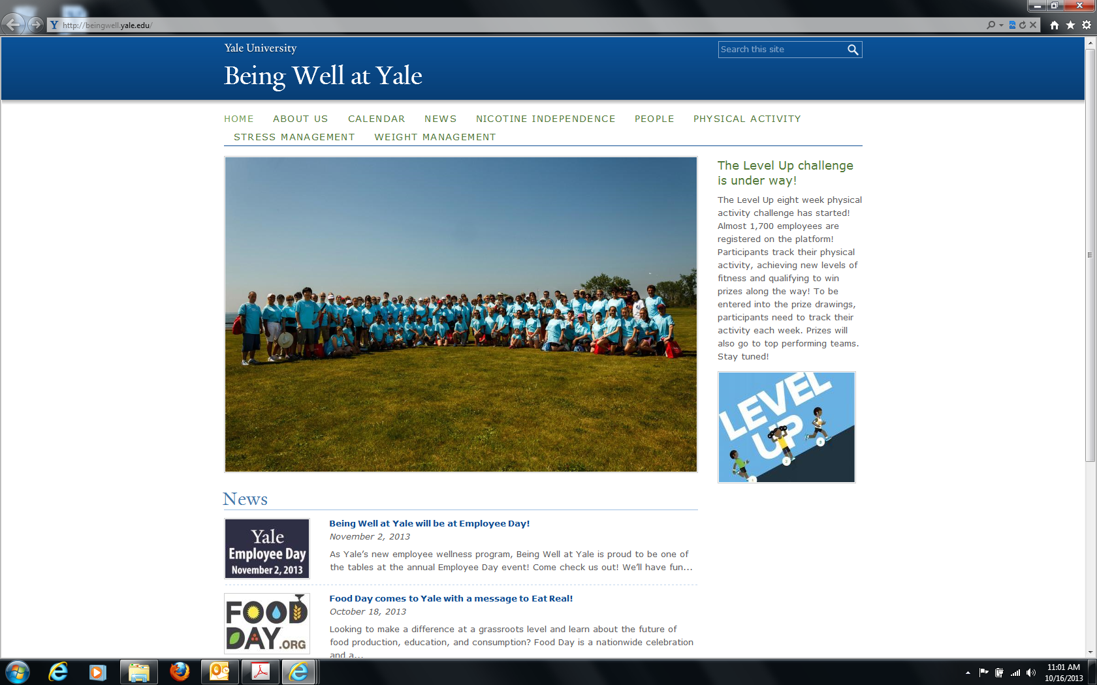
- Then click on the first bullet, Weight Watchers ® at Work.
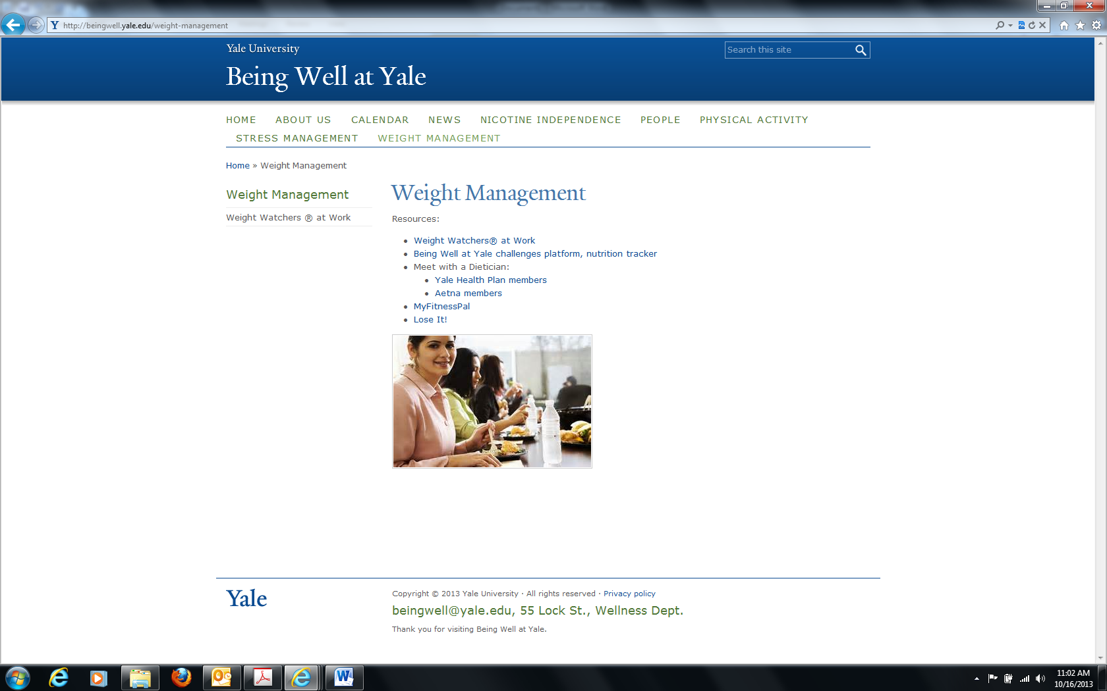

- You can access the form by clicking the Weight Watchers ® button on the right.
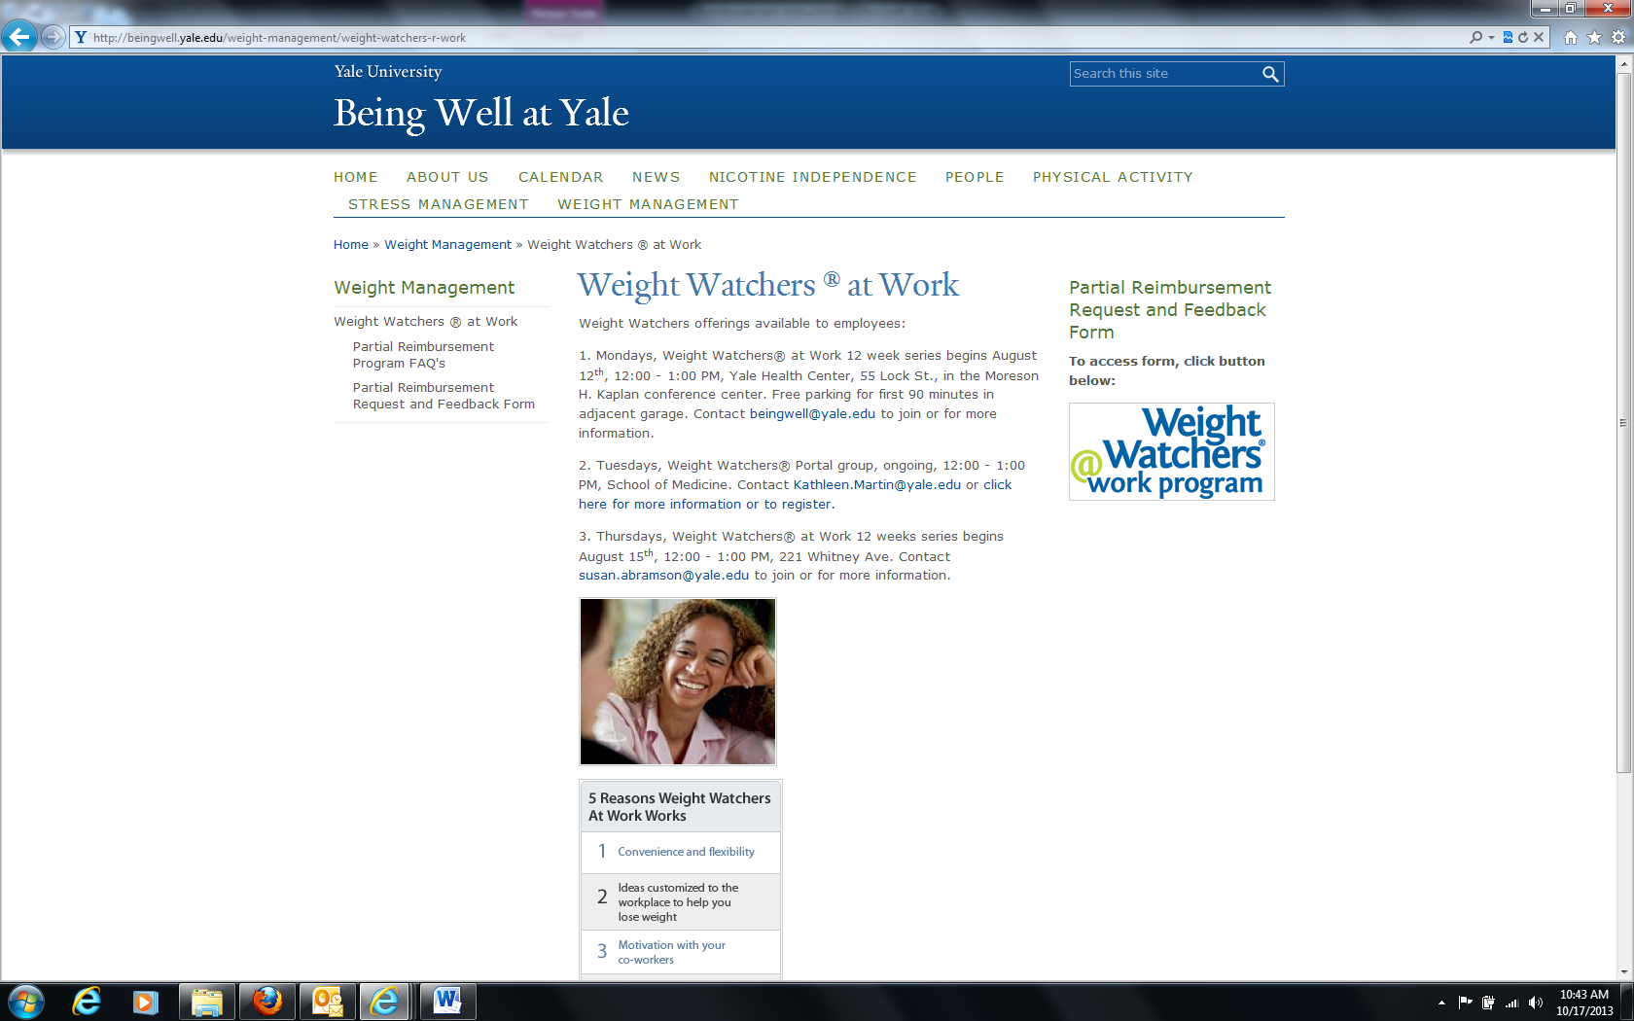
- You will then be redirected to Log In to CAS using your net id and password.

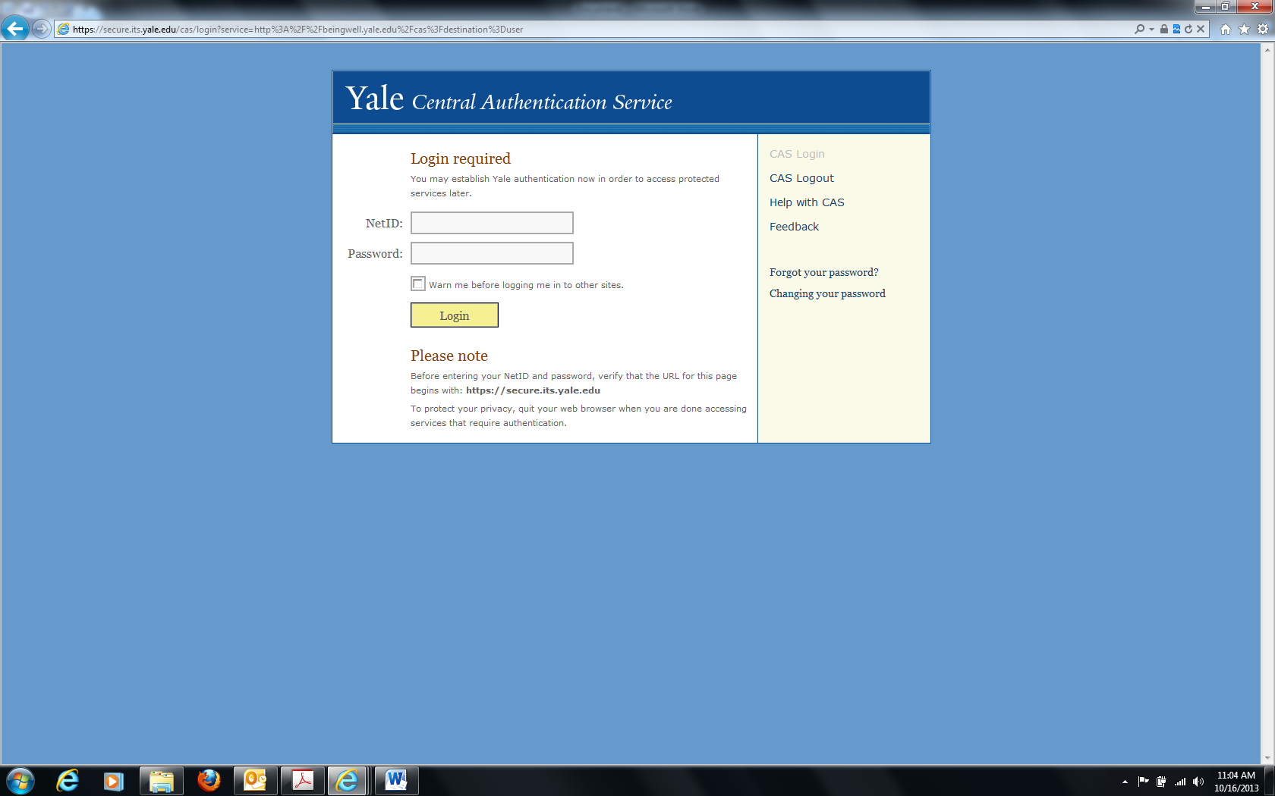
- Complete the form.
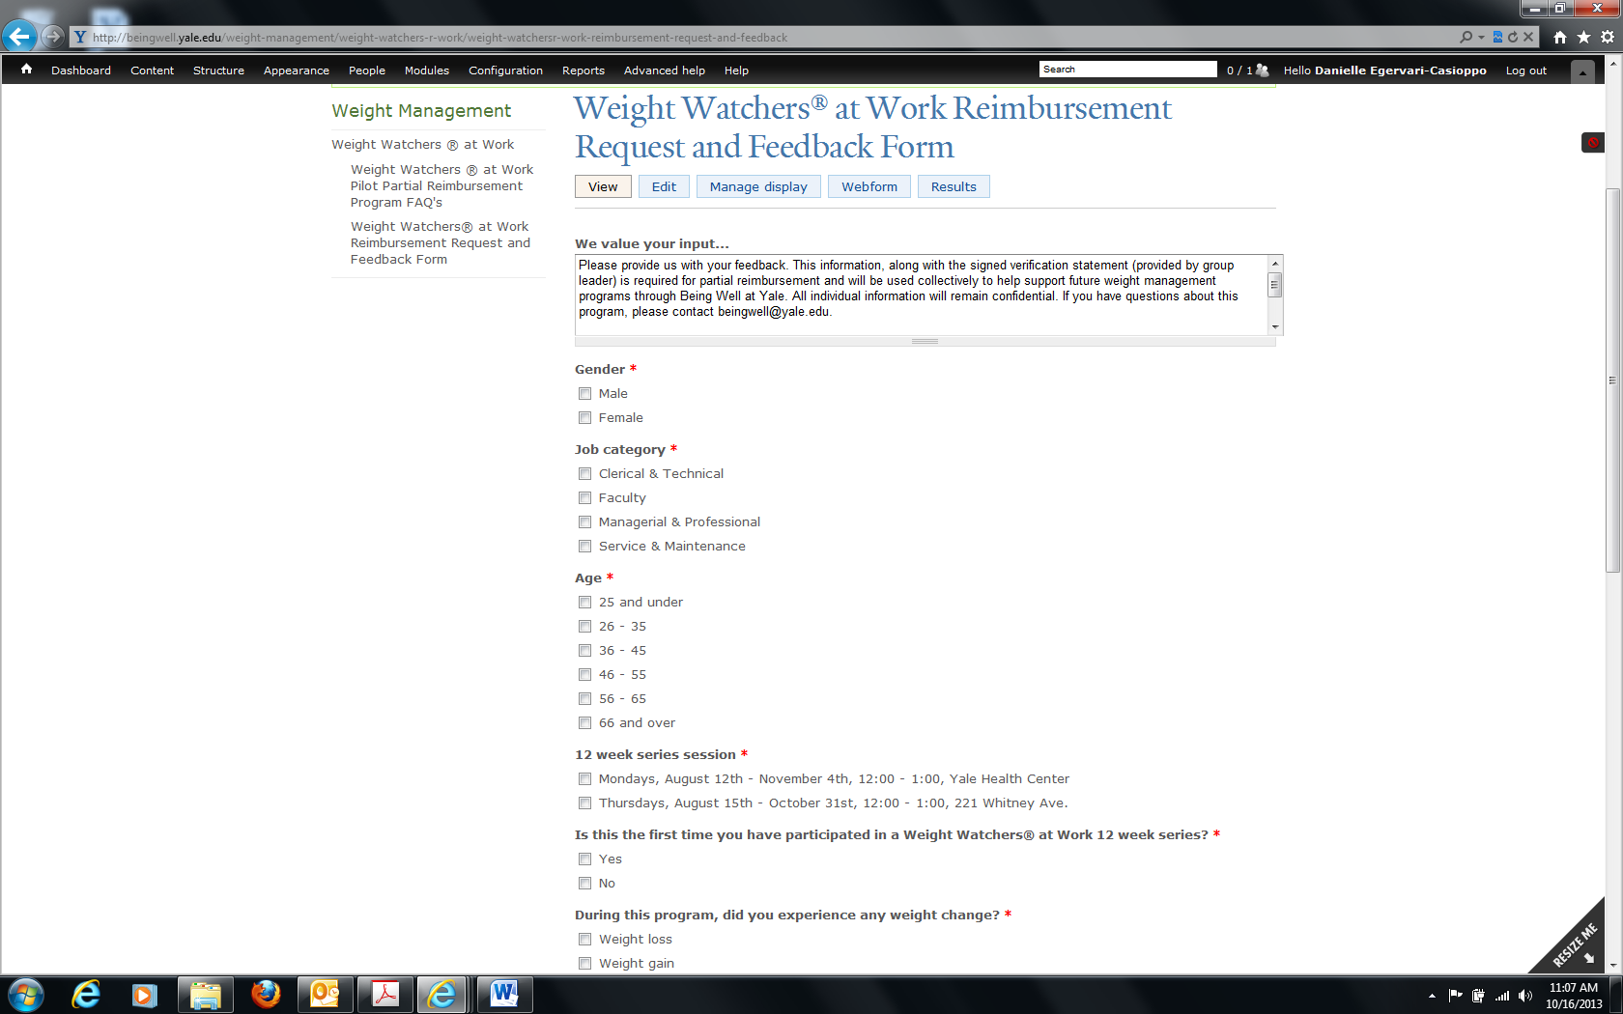
- Click the submit button once finished.
